‘Germany my Beloved Land’
Gareth Jones and the Nazis

[Teresa Cherfas examines controversial material that has emerged about the young Welsh journalist, Gareth Jones, who was killed in mysterious circumstances in Mongolia, a couple of yeasrs after exposing the famine in Soviet Ukraine.]

In researching the film, Hitler, Stalin and Mr Jones, one of Gareth Jones’s great-nephews showed me a letter. It was dated 2 September 1935 and was from Dr Ing. Wilhelm J. Wiss. Addressed to ‘My dear parents of my good friend Gareth Jones’, it was a letter of condolence. Gareth Jones had recently been shot dead by Chinese bandits who had held him captive for two weeks on the plains of Inner Mongolia:
We two had spent so many happy hours of fine times and interesting conversations together, in England, in Germany, on ocean boats etc. that Gareth and I seemed to be connected with some sort of common destiny.
Wiss’s letter mentions two enclosures: an article he had written about Gareth for a German newspaper, and a translation of that clipping for their own reading. Mrs Annie Gwen Jones kept everything to do with her only son: all his letters, diaries and notebooks, all his articles, photographs and the paraphernalia of souvenirs from his foreign trips – Soviet posters, Chinese silks, signed portraits. But there was no sign of the two enclosures. As time passed, and war with Germany approached, these were perhaps mementos of their beloved son that the Joneses would prefer not to keep. For without doubt Gareth loved the enemy: ‘No one else has ever been so sincere, fair, and sympathetic also with my country and the man all Germans love so much,’ Wilhelm Wiss wrote to them. In 1935, there was no mistaking the identity of ‘the man all Germans love so much’.

The address Wiss gave at the top of the letter was his office address in Berlin: the German Shortwave Station. Wiss was a Nazi propagandist. He had met Jones the previous year when they were both crossing the Atlantic from the United States. Wiss, I discovered, had subsequently facilitated introductions to top-ranking Nazis, including \Hitler himself. The question that intrigued me was whether the ever-inquisitive Gareth Jones had cultivated Wiss despite or because of his views.

By the time he died, the young Welsh journalist had already manoeuvred himself close to the heart of both the Soviet and Nazi regimes, each peddling their own vision of a new world order. Unlike many of his more celebrated contemporaries, he had been quick to to see through the pretensions of the Soviet Five-Year plan and to grasp the reality of the suffering and death it was inflicting on the peasants. What was less clear was Jones’s attitude to Hitler, whose rise to power was equated by many in the late 1920s and early ’30s with the restoration of Germany’s self-respect. Many saw Hitler as an admirable firm hjand when most Western leaders were wilting before the onslaught of unemployment and recession.

Gareth Jones had first visited German in 1923, and since then had been back at least once every year. Many of his letters

ulierc art no tear answers, but J(~I1~’S’S c1o~ affln~t~ With GermahlY is cerLiinly part of the story. I³erlin Was a fllagnct f~r journaIist’~ ~ those days ~nd Jones ~vas n ,~ alone in makjz~ ~
there after leaving M~~co~ in March I33. Malcolm

Mu~e1~ had leit Moscnw JUS~ as his three Unsigned artjcl ~₁eak1ng the story of the Soviet famine Wt~fl( to press, days
before Jones .5 press con IerencL. Hf! tO(i interrupted hi~ journey
~ f3crlifl~ At that time, the two capital Cities offered a stark choice National Socialism and Communism were ideologies wh4~e impkmentation promised to ~change moribund
talism for a future that would be bright with hope arid
ty To be against one meant aligning Oneself with the The choice defined a generation
a rnodern-da’~ Icarus, Gareth Jones’s wings of feathers wax melted when lie flew too do’: to the sun. Etc died
any’ne could know the flnal outcom~ of the battk
Hftle and ~t~lin. Rarely for the time, he saw the for abomination in both regimN, even if his greater Germany created ambiguities. As a journalist and a
operator~ he was fascinated by power, and his
got him to its white-hot centre. But like Icarus, he death. Reading about Gareth in the Vólkischer had made me shi’.er, 1 felt I could understand why
might not have kept Wiss’s enclosures Like so cd wax and feathers they would have been a bitter of their son’s hubris.

~~ii JoneS kept everything to (10 with I1~r only ~, ~ lcttcrs~ dwrtes and notebooks, all hi₅ arij
tile paraph’fl~’1 of SOUV unir, from hic’ Pliotograpi ~
fr~rcign trip~
~osrerS Chinese silks, signed portraits l3ut tlh~f~ ‘~~dS fl~ sign
two enclosures As time passed, and ‘var wj~
~pproach1~h. these were perhaps memento₅ of tl~eir belo~’~(j
~ that the Joneses would prefer flot to keep io~ Wj~~_{10~1~} doubt Gareth loved the enemy ‘No LI1I else has ever been so çjnccrt~ fair, and sympathetic a1s~ witl~ n~ C0UntTy and the man all Germans love so much,’ Wilhelm w~. wrote t~ them In i935~ there was no mistaking the identity oI’the man au Germans love so much’.
The add1e~S Wiss gave at the top of the letter W~s his ofiicc addre5c ifl B&lifl the German Shortwave Station Wj~ ~ a Nazi propagandist. He had iy~t Jones the previouc year when both ‘.%erC crossing the Atlantic from the United Stares. W1s~, i discovered, had subsequently facilitated introductIons ~ top~ranking Nazis, including Hitler himself The question tl~ai intrigued me was whether the ever-inquisitive Gareth Jones had cultivated Wiss despite or because of his views.
By the time he died, the young Welsh journalist had already manoeuvrered himself close to the heart of both the Soviet and $azi regimes, each peddling their own vision of a new world order. Unlike many of his more celebrated contemporaries, he had been quick to see through the pretensions of the Soviet Five-Year plan and to grasp the reality of the suffering and death it was inflicting on the peasancs What was less clear was Jones’s attitude to Hitler, whose rise to power was equated by many in the late 1920S and eart~ ‘305 with the restoration of Germany’s self-respect. Many saw Hitler as an z~dmirable firm hand when most Western leaders were wiltLng before the onslaught of unemployment and recession.
Gareth Jones had first visited Germany ~fl 1923k and s~ncc th~~ had been back at least once every )‘ear. Many of his lette~ show Sympathy for the people and the Countr that dec~cn~d withtime, On that iIrst visit, he found a countrY experiencing
~UnaWay inflation as a result of the ~~in~Ciflg repar~1t1Ol~

(₁\SCI¹ Janec kept everything to do With her Only s all hi~ lettcrs~ cIijrIeS j~d notebooks, null his articl~ PhOtot~rdp} and che paraph nalia ~ SOUVcnir from his foreign tri~
rosters. Chinese silks, signed portraits I3tit ther~ ~ ~ Sign ₀(thc two enclosures A~ time passed, and “ar ‘~ith
~pproached these were perhaps mementoc Of their belov~~ ~on that the Joneses would prefer nOt to kc~~p. For wihotit doUbt Gareth loved the enemy: ‘No ~ else has ever been so cincere, fair₁ anci sympathetic also ~~ith my cOunt~ and he man all Germans love so much,’ Wilhelm W1~~ wrote to them. In 935 there was no mistaking the identity of’the man aLl Gerfllafls love so much’.
The address Wiss gave at the top of tiii letter was his office address in Berlin: the German Sh~itwave Siàtj~~~ ~ a Nazi propagandist. 1-le had met Jones the previous year wt~n ~th were crossing the Atlantic from the United States. Wiss, I discovered, had subsequently facilitated introductIons to top~ranking Nazis, including Hitler himself The question that
intrigued me was whether the ever-inquisitive Gareth Jones had cultivated Wiss despite or because of his views.
By the time he died, the young Welsh journalist had already manoeu’~Tered himsejf close to the heart of both the Soviet and Nazi regimes, each peddling their own vision of a new world orders Unlike many of his more celebrated contemporaries, he had been quick to see through the pretensions ol the Soviet Five~Year plan and to grasp the reality of the suffer ing and death it was inflicting on the peasants. Wh~it ‘~‘~ k~ dear ~s Jones’s attitude to H itler, whose rise to power was equated by many in the late 1920S and early ‘30s with the restoration of Germany’s sclf~respect. Many saw Hitle as an admirable fIrm hand when most Western leaders were wilting before the onslaught of unemploymwnt and r~~ceSSLOfl.
~areth Jones had first visited Germany ~fl 1923 ~nd inc~ then had been back at least once CVCI) year. Many of his Letters show sympathy for the people a~d the countrY thu deepened With time. On. that first visit, he found a country ~ fliflaway inflation as a result of the swingeing repar~tiOlls

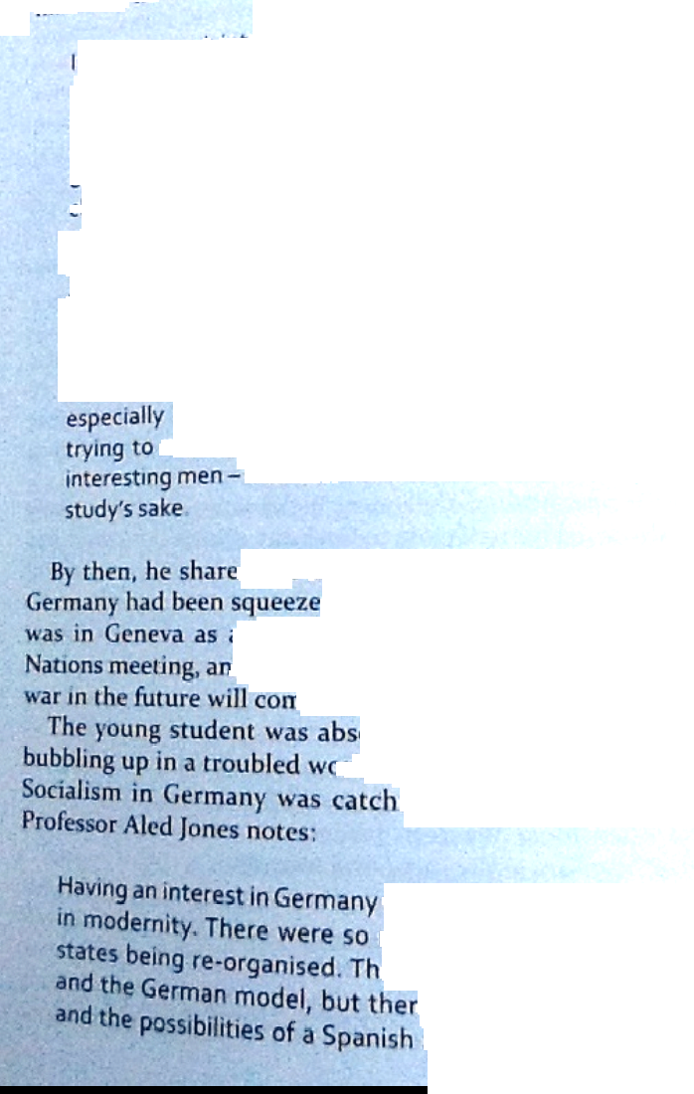
by the TreatY of Vi~i~aillCS lie (ill eddy ~ GerU~ and ~ fluenhIY and had become ~ idealj~tk
youth ~~iegatc ~ the ~cagUC O~ ~ti~rn’~ !ii 191 ~ aged ninetC~’ he wrOte (0 his parents:

an~ ve1~ muCh ntere5t~ in peoples and countries and ~ modern EuroPe, espeCia~Y. I would a thousand times prefer to use my ~~~wledge of languages with ~r aim to ₀bta’n’~Y a poSitlOfl where I could meet interesting people r,f all natioflal jteS, and where I could really find out the rharacteri5t~cS of the nations of today; Why there ~ wars, and how they ~ be prevented; how national, SemitiC and religious prejudices can be destroyed, and why they exist, why there are certain movements, literary or political in certa~fl countries; why people of races have certain ideals, why certain nations have their characteristics reflected In their literature. All that and learning all these things by travelling, and make people speak out their ideas and meet interests me much more than study for

d the increasingly fashionable view that d too hard. In September 1926, he
rn enthusiastic observer to a League of d came away convinced that ‘the danger of
w from economic reasons’s orbing all the ideas that ~t~re
)rld. And the success of National ing many pcople’~ eye AS

was like having an interest many different modek of ere was the Soviet model
e was an Italian mode’ republic. Europe WaS ~

chaflgn9 place and people were avidly reading and debating what the future Would be Ilk,?.

By 1928 on a tour OlGeririany, Jorms wr~)tl to his parents:

Germany strikes me as being remarkably prosperous —beautiful new buildings everywhere The COUfltry and the people look much better cared-for, clean and prosperou~. than at home~ It is a contrast to the first time i was in
Germany during the inflation when everything was very bade I really cannot understand how they manage to build such wonderful schools and museums, stations, etc. and pay reparations at the same time~ I admire the Germans more and more every time I come here.

The dilemma, if it. was one, came to a head in Februai-~ ~
By then, Gareth Jones had becomc~ a successful freelance journalist, but he still clung to the coat-t~iils of his first employer, former Prime Minister Da~id Lloyd George As h~ wrote to his parents from the train on his way to Berlin: 1 remain a member of L.G.’s staff entr~ nous at a nominal salary-.~ until end of March; but it is worth everything to me to go to Germany as his secretary it gives me a wonderful entrée₄’ On this occasion, possibly aided by Wilhelm Wiss, he got hImself a seat aboard Hitler’s private plane, watched as the Führer worked a mass rally of Nazi supporters in Frankfurt.
and dined privately with Dr Josef Goebbels
On his return, he reported back to Lloyd ~ who took the trouble to write to him, saying how much he appreciated the inside ~‘iew Gareth had given him of what ~ happening in Germany. Jones’s articlec from this tripe published in thc Western Mall, were indeed both w_{41~}ll~ba1an~~l and reasonablY uriblinkered. They do report die enthusiasm that greeted HItler’s appeeu~ances, and the pOW ~ Of’ his orator~ He CVCfl ~nte~ that there could bc lessons to be Icarnt for wales in the N4~t PIan~ for tackling youth unei~np!0Ym~t v~ ith theit~ laboUf camps, But he also warns of the thre~tt to defl1’~ ifl

fGcrmaflY~ my Beloved

er article, publ”~~’~ ~rn June ~ ‘~3e Cle~l~
Gernu.mY A _{1~~}ding o the cenu’aI place ~
sh~1~sS jones~ UtICr ~ game plan. Jones wrote that hc found ~t occuP1C~t ~ the medi~t~ pronoU11Cem~1tc ~“ leading ~ hard r~ square
~~ith i,~’hJt he saw arOUfl~¹ him

As I istened to him I felt as if I had been transported beck
maflY centUt~, to an age of witchcraft and black mayic, ~o unreal was his description of the SO-called machinatIon⁵ of the Hebrew race.
When I got out into ~he streets of Berlin I almost imagined that a pogrom might take place, so burning had been the hatred, ~hih the Nazis had expressed for the Jews But nothing happened₁ and the streets were as quiet and orderly and the people as calm as ever

Dr Toby Thacker of Cardilt University is illuminating about Gareth’s attitude to Germany;

In the first months of the Nazis’ coming to power in ig~33, many people in Germany, and reporters from outside, wanted to play down Nazi anti-Semitism, seeing it as an unpleasant but fairly marginal aspect of Nazism that will come to be seen as no more than a rabble-rousing t€hnique for electioneering purposes. Gareth didn’t fall into that tendency at all. He recognised that anti5emsti~m was very central to Nazism, arid in this he’s very much in tune with the latest historical thinking on Nazi
Germany

But Thacker finds rh~t in other aspects, Gareth falls tub
rather stereotypical VICW held of Germany by 50 many
)Utsjdcrs

Thdt th~ was a place of good order, that there was good behaviou₁ on the streets, that everything was clean and tidy, that people were well-mannered and well behaved

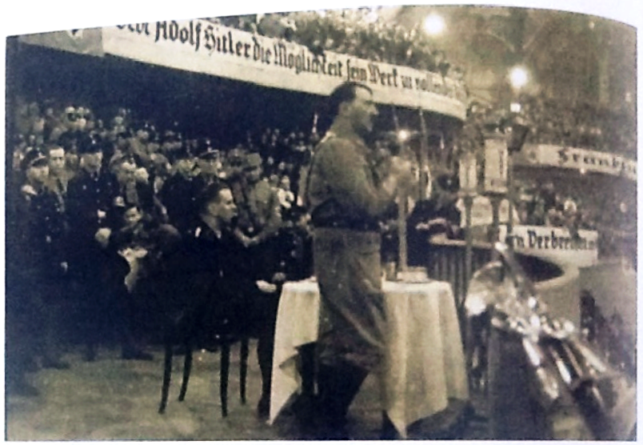
71
‘GermaflV~ my Beloved lan~j’

Ont it Cir~1h 1r&~.~ 0’. u photn~i. t~iken 3t .1 mII~ in 1:r3flkfurt in 1914 Photu ~ National I i~’r₁r~ ci

cnjo~ in the rather puritankLd atmosphere in Wales in the early ()2os.
Gareth becdrne a regular visitor to Germany and. the Waldheim area, where I lalerkorn lIved, and th~ continued
h~’ir walks ~n the Erzgebirgc mountains, where Gareth also learnt to sing German folk’~uugs and enjoy lo~al customs~
Atier leaving Moscow in March 19~3, Gareth sto~’p~d otitO see Haferkorn in I)anzg en route to Rcrliri ~ u r~onth~ later. he returned to Gerrndny in order to gather mat crial for a ~cric~ of sIx article.., called ‘Germany Under hitter’, ~~htch ~ published in the West urn A!ai/ in edrly June 19~ Qn~i flW11~ h~ Slopped In Danzig to see hk old ii ~t.uid flaI’êi~k~” pId
mention to him that in his ih~’nce ~ had ₁₀í~~d
th~ NSDAP arid become a N₄i,j~
The articles GaRt Ii prci(lw ed are a b Iliant aii&I ~ expos,t_{10~} ‘I the f~Cts₁ at pains to e’pI~In tt~ R~aders ho’~’ things might have ~ I from the pci spe I lye VI

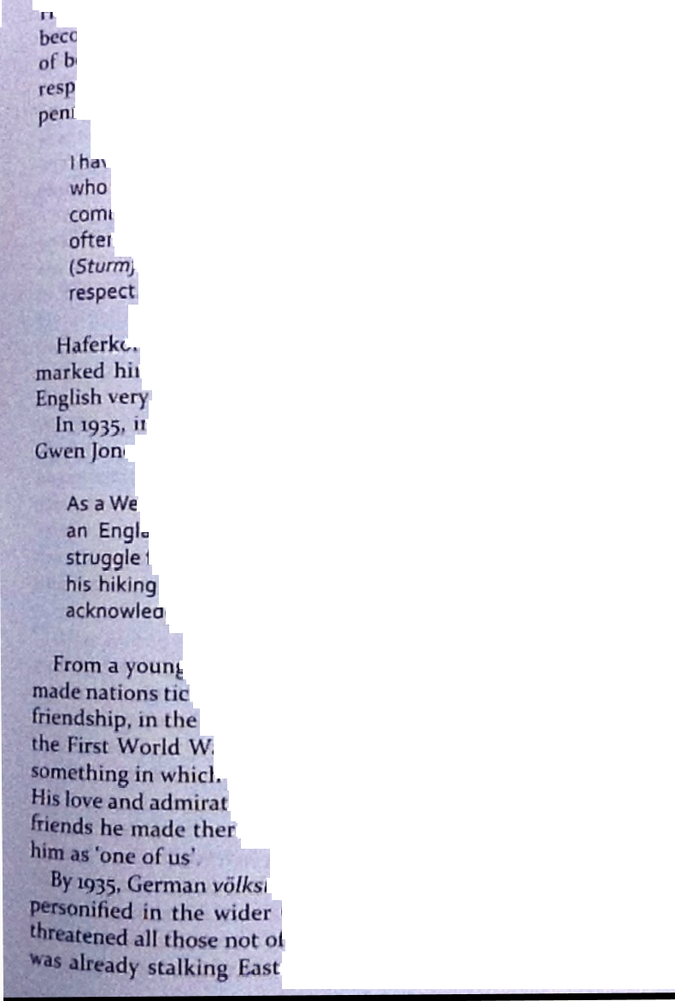

‘-ge doesn’t condone but he ClUeS explain 1 hf~rkorn w~ )ming known to his Nazi mentois f~r his ‘Uflcommr,,₁ gift eing able to bring English studerit~ to Undertar~d and ect Nazi Germany’~ This letter oi rCCO1flfl1efld~~ Ion W~q ned by the Gati!eiter ui Danzig in Mar~h 19 ~

-ie known Mr Haferkorn as an absolutely reliable Nazi, openly speaks his mind and knows how to be a good ade. And whose sure and thoughtful worldvevi was
, of valuable service ~o me. His SA lieutenant fOhrer) confirms my personal opinion in every

irn’s frequent visits to England and Wales had also
‘n out as someone ‘who knows England and the
thoroughly’.
i that small local supplement kept by Mrs AnnIe
es, Haferkorn had written of his dead friend

Ishman, because he proudly denied being called ~nder, Gareth had a sharpened sense of the forGerman vö!k.stur(folk identity).~ No wonder comrades took him to their hearts and now
~ge him in proud sorrow, for he was one of us.

~ age, Gareth had ~anted to understand what
k. When he and Reinhard had struck up their wake of the collapse of empires wrought by
ar, nationalism was on the rise and it was
‘ the two men shared a legitimate interest.
ion of Germany was deepened by the firm
e, but the risk he ran was that they ~a~s

tur, which he’d taken to his heart, was
German välk, whose Nazi ideology
C the Master Race. and whose Euhrfr

em Europe foi’ Iebeflsratlnh’ ~areth

GermaflV~ my BCIOVOd

tlidflt ~i’ ~ to see his great fr_{1~}fld riSC t(~ head the lInglish SC(t_{1~}
oi^{t} j₁k’rS foreign 1ThtW~’~ ~~₁)j(k(1s1ing Policy Department
wherc he %%irkcd on Berlin RadIo”~ wartime E)rOpaga~~ broadct~t~ by Lord Flaw Haw. That wm still to come. Whethc~
his parents undcrst00d Ge~rrnafl )1 not, 1-laferkorn’s obit~_{1~1~01}
~~aretl1 Jones may have ~ I~~OCUOUS enough When it Was writtcIL but b~’ the rime the ~ccond world war was over, Europe was a ~ry different pla:e and Hafeikoru’s choice o~ ~ouiJ havc appeared more ~nistcrIt didn’t take long to trace’ the other German obituar-y the
newspaper article that Wilhelm Wiss had enclosed with his icttcr to ~areths parentS Wiss had written it himself, and ~ his letter to the Joneses he described how he ‘immediately
wcflt ovef to our biggest newspaper. the Völkjscher !3eobachter, the organ of our Government, to ask for the soonest possIble publication.
HItlL’~ and the National Socialist Party had been in power for tWo years by then The Vólkischer &obachter, with its Swastika masthead and Gothic German script, was the organ of the Nazi government. Wiss’s artick in the Nazi mouthpiece is titled Germany was his beloved land - a man from whom much was expected.’ Wiss quotes from several letters Gareth Jones had written to him. One, dated iS June ~ may hold thi’ key to their relationship:

You ~houId not take seriously what I said about Hitler arid the Nazi movement. That’s what I always do whenever I have ~ discuss~o~ with someone of strong opinions, I aliays take the opposite view so that the ideas will become clearer to me and the proponent will argue with qreit~~ convict ion,

Wa Gareth Jones apologising cleverly tüi having embjrrassed W~ by criticising Hitler, or did his balaflt~ iuurnalism conceal an underlying love ot (~rmany th~it the br~t~iJj~~ of the Nazis had not yet ohliterjted? Wiss qU0t~ from anothir letter he received from Jones’
Thr cpr~acJ of the VoIki.-.~h₄” B,’til’ili’Irtr ~bIch ~rncd an obituar.’ of Gareih Jont~s in
August 1935

Germany is and remains my beloved land and I am
extremely happy to live there.

That was 1933. But in Jones’s defence, one should sa~ that even three years after that Hitler was still seen as a good thing by many influential Britons. David Lloyd George called him ‘the George Washington of Germany’ after meeting Flitter in
1936:

Whatever one may think of his methods — and they ~re certainly not those of a parliamentary country there can be no doubt that he has achieved a marvellous transformation in the spirit of tle people, in their attitude towards each other, and in their social and economic outlook ... There is for the first time since the war ~‘ general Sense of security The people are more cheerful

